

**Mawlana Bhashani Science and Technology University**

**Lab-Report**

Report No: 06

Course code: ICT-4202

Course title: Wireless and Mobile Communication Lab

Date of Performance: 25.09.2020

Date of Submission: 30.09.2020

**Submitted by Submitted To**

Nazrul Islam

Assistant Professor

Dept. of ICT

MBSTU.

Name: Mohammad Mehedy Hasan

ID:IT-16024

4th year 2ndsemester

Session: 2015-2016

Dept. of ICT

MBSTU.

**Experiment No: 06**

**Experiment Name: Switching an interface to move a host around a network using mininet.**

**Objective:**

One of Mininet's most powerful and useful features is that it uses Software Defined Networking. Using the [OpenFlow](https://www.opennetworking.org/sdn-resources/openflow) protocol and related tools, switches can be programmed to do almost anything. OpenFlow makes emulators like Mininet much more useful, since network system designs, including custom packet forwarding with OpenFlow, can easily be transferred to hardware OpenFlow switches for line-rate operation. The objective of this experiment:

* Downloading and running mininet on virtual machine(VM)
* Switching an interface to move a host around the network
* Using mobility.py

**Steps:**

1. Creating network
2. Adding controller
3. Adding hosts
4. Configuring hosts
5. Starting controller
6. Starting 3 switches
7. Testing network
8. Testing connectivity
9. Identifying switch interface for host
10. Moving host to 3 switches respectively

**Source Code:**

|  |
| --- |
|  |
|  | from mininet.node import OVSSwitch  from mininet.net import Mininet |
|  | from mininet.topo import LinearTopo |
|  | from mininet.log import info, output, warn, setLogLevel |
|  |  |
|  | from random import randint |
|  |  |
|  |  |
|  | class MobilitySwitch( OVSSwitch ): |
|  | "Switch that can reattach and rename interfaces" |
|  |  |
|  | def delIntf( self, intf ): |
|  | "Remove (and detach) an interface" |
|  | port = self.ports[ intf ] |
|  | del self.ports[ intf ] |
|  | del self.intfs[ port ] |
|  | del self.nameToIntf[ intf.name ] |
|  |  |
|  | def addIntf( self, intf, rename=False, **kwargs ): |
|  | "Add (and reparent) an interface" |
|  | OVSSwitch.addIntf( self, intf, **kwargs ) |
|  | intf.node = self |
|  | if rename: |
|  | self.renameIntf( intf ) |
|  |  |
|  | def attach( self, intf ): |
|  | "Attach an interface and set its port" |
|  | port = self.ports[ intf ] |
|  | if port: |
|  | if self.isOldOVS(): |
|  | self.cmd( 'ovs-vsctl add-port', self, intf ) |
|  | else: |
|  | self.cmd( 'ovs-vsctl add-port', self, intf, |
|  | '-- set Interface', intf, |
|  | 'ofport_request=%s' % port ) |
|  | self.validatePort( intf ) |
|  |  |
|  | def validatePort( self, intf ): |
|  | "Validate intf's OF port number" |
|  | ofport = int( self.cmd( 'ovs-vsctl get Interface', intf, |
|  | 'ofport' ) ) |
|  | if ofport != self.ports[ intf ]: |
|  | warn( 'WARNING: ofport for', intf, 'is actually', ofport, |
|  | '\n' ) |
|  |  |
|  | def renameIntf( self, intf, newname='' ): |
|  | "Rename an interface (to its canonical name)" |
|  | intf.ifconfig( 'down' ) |
|  | if not newname: |
|  | newname = '%s-eth%d' % ( self.name, self.ports[ intf ] ) |
|  | intf.cmd( 'ip link set', intf, 'name', newname ) |
|  | del self.nameToIntf[ intf.name ] |
|  | intf.name = newname |
|  | self.nameToIntf[ intf.name ] = intf |
|  | intf.ifconfig( 'up' ) |
|  |  |
|  | def moveIntf( self, intf, switch, port=None, rename=True ): |
|  | "Move one of our interfaces to another switch" |
|  | self.detach( intf ) |
|  | self.delIntf( intf ) |
|  | switch.addIntf( intf, port=port, rename=rename ) |
|  | switch.attach( intf ) |
|  |  |
|  |  |
|  | def printConnections( switches ): |
|  | "Compactly print connected nodes to each switch" |
|  | for sw in switches: |
|  | output( '%s: ' % sw ) |
|  | for intf in sw.intfList(): |
|  | link = intf.link |
|  | if link: |
|  | intf1, intf2 = link.intf1, link.intf2 |
|  | remote = intf1 if intf1.node != sw else intf2 |
|  | output( '%s(%s) ' % ( remote.node, sw.ports[ intf ] ) ) |
|  | output( '\n' ) |
|  |  |
|  |  |
|  | def moveHost( host, oldSwitch, newSwitch, newPort=None ): |
|  | "Move a host from old switch to new switch" |
|  | hintf, sintf = host.connectionsTo( oldSwitch )[ 0 ] |
|  | oldSwitch.moveIntf( sintf, newSwitch, port=newPort ) |
|  | return hintf, sintf |
|  |  |
|  |  |
|  | def mobilityTest(): |
|  | "A simple test of mobility" |
|  | info( '* Simple mobility test\n' ) |
|  | net = Mininet( topo=LinearTopo( 3 ), switch=MobilitySwitch ) |
|  | info( '* Starting network:\n' ) |
|  | net.start() |
|  | printConnections( net.switches ) |
|  | info( '* Testing network\n' ) |
|  | net.pingAll() |
|  | info( '* Identifying switch interface for h1\n' ) |
|  | h1, old = net.get( 'h1', 's1' ) |
|  | for s in 2, 3, 1: |
|  | new = net[ 's%d' % s ] |
|  | port = randint( 10, 20 ) |
|  | info( '* Moving', h1, 'from', old, 'to', new, 'port', port, '\n' ) |
|  | hintf, sintf = moveHost( h1, old, new, newPort=port ) |
|  | info( '*', hintf, 'is now connected to', sintf, '\n' ) |
|  | info( '* Clearing out old flows\n' ) |
|  | for sw in net.switches: |
|  | sw.dpctl( 'del-flows' ) |
|  | info( '* New network:\n' ) |
|  | printConnections( net.switches ) |
|  | info( '* Testing connectivity:\n' ) |
|  | net.pingAll() |
|  | old = new |
|  | net.stop() |
|  |  |
|  | if __name__ == '__main__': |
|  | setLogLevel( 'info' ) |
|  | mobilityTest() |

**Output:**

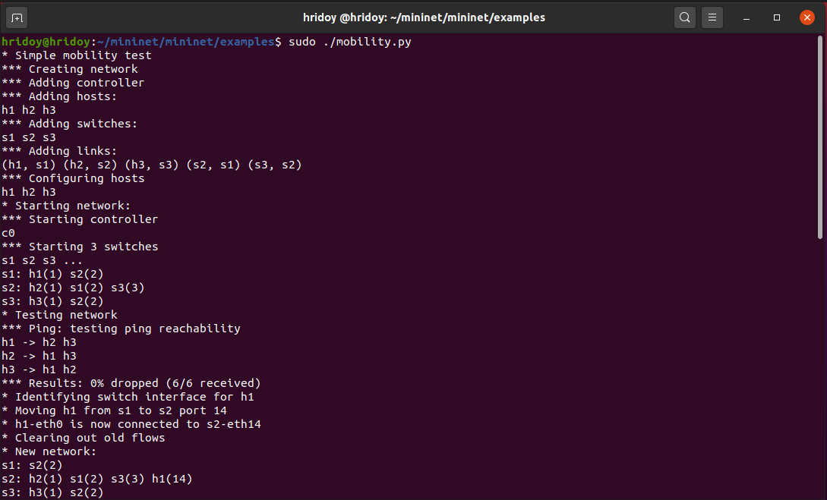

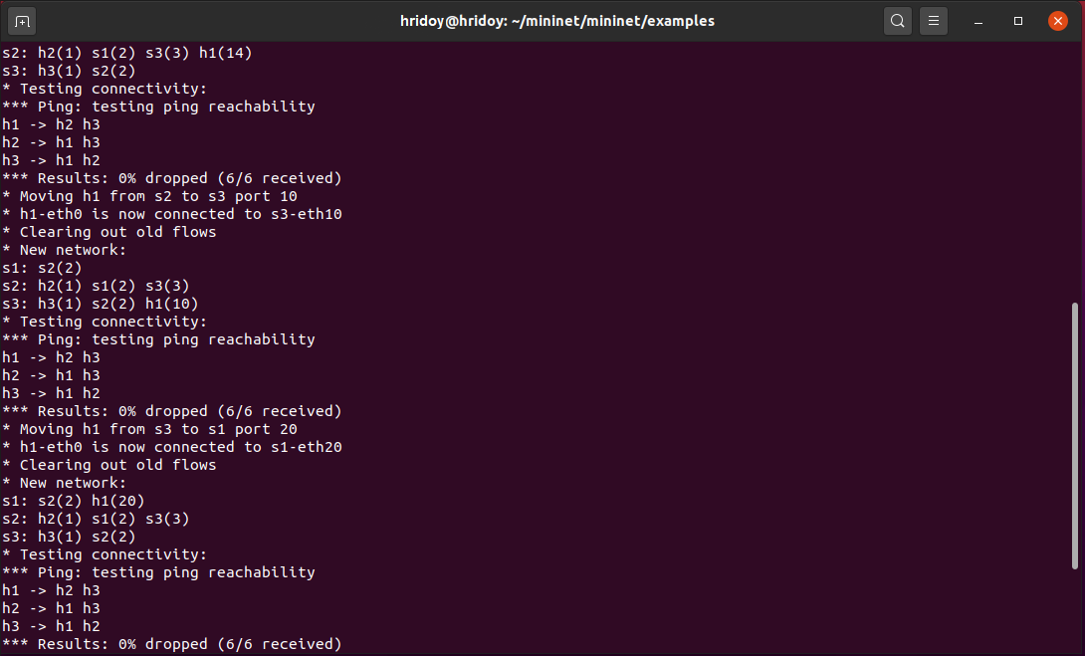

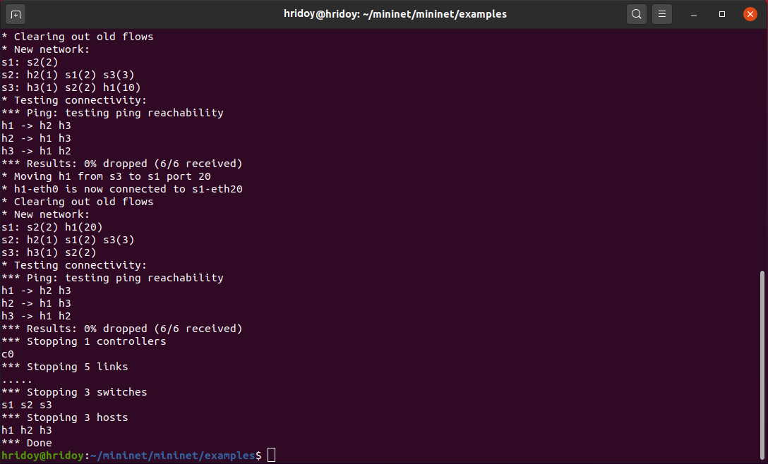

**Conclusion:**

Mininet enable us to quickly create, interact with, customize and share a software defined network prototype, and provides a smooth path to running on hardware. Using mininet in this experiment, a host in the newtwork was switching from one switch to another in different ports with 0% drop. The host was switching and it shows us how the wifi mobility works.